SQL Queries

1. KPI’s

-- Total Sales of Pizza

SELECT SUM(total_price) AS Total_Sales FROM pizza_sales;

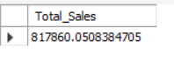

-- Average Order value

SELECT sum(total_price)/COUNT( DISTINCT order_id) AS Avg_order_value FROM pizza_sales;



-- Total Pizza's sold

SELECT sum(quantity) AS Total_pizza_sold FROM pizza_sales;

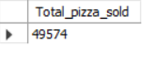

-- Total Quantity Sold

SELECT COUNT( DISTINCT order_id) AS Total_Quantity_sold FROM pizza_sales;

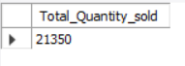

-- Average Pizzas per order

SELECT round(sum(quantity)/COUNT( DISTINCT order_id),2) AS Avg_pizzas_per_order FROM pizza_sales;



2. Chart Requirements

-- Hourly Trend For Total Pizzas Sold

SELECT DATE_FORMAT(order_time, '%H') AS Order_Hour, SUM(quantity) AS Total_pizzas_sold

FROM pizza_sales

GROUP BY DATE_FORMAT(order_time, '%H')

ORDER BY DATE_FORMAT(order_time, '%H');

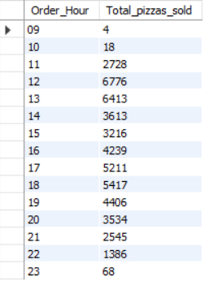

-- Weekly Trend for the Total Orders

SELECT week(order_date,3) AS Week_Number,year(order_date) AS Year ,COUNT( DISTINCT order_id) AS Total_Orders

FROM pizza_sales

GROUP BY Week_Number,Year

ORDER BY Week_Number,Year;

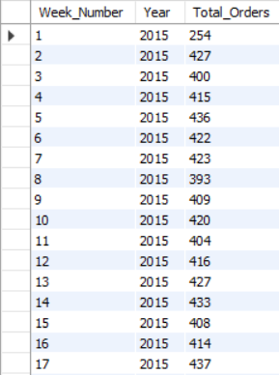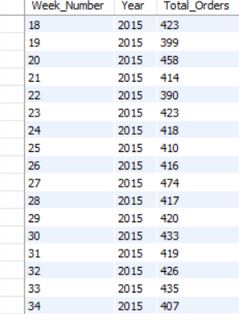

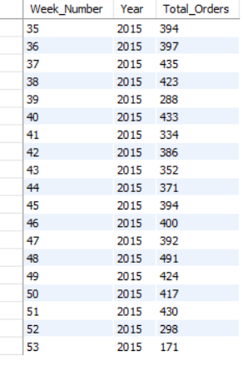

-- % of Sales By Category

SELECT pizza_category,sum(total_price) AS Total_sales_by_Category,

sum(total_price) * 100 / (SELECT sum(total_price) FROM pizza_sales) AS Percent_Of_Total

FROM pizza_sales

GROUP BY pizza_category;

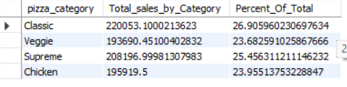

**With Filter**

SELECT pizza_category,sum(total_price) AS Total_sales_by_Category,

sum(total_price) * 100 / (SELECT sum(total_price) FROM pizza_sales WHERE month(order_date) = 1) AS Percent_Of_Total

FROM pizza_sales

WHERE month(order_date) = 1

GROUP BY pizza_category;

*** WHERE month(order_date) = 1 *to get the % for a particular month 1 indicates Jan*

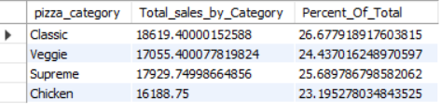

-- % of Sales By Size

SELECT pizza_size, cast(sum(total_price) AS DECIMAL(10,2)) AS Total_sales_by_size,

round(sum(total_price) * 100 / (SELECT sum(total_price) FROM pizza_sales),2) AS Percent_Of_Total

FROM pizza_sales

GROUP BY pizza_size

ORDER BY Percent_Of_Total DESC;

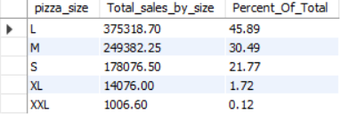

**-- % of Sales By Size Quarter**

SELECT pizza_size, cast(sum(total_price) AS DECIMAL(10,2)) AS Total_sales_by_size,

round(sum(total_price) * 100 / (SELECT sum(total_price) FROM pizza_sales WHERE quarter(order_date) = 1),2) AS Percent_Of_Total

FROM pizza_sales

WHERE quarter(order_date) = 1

GROUP BY pizza_size

ORDER BY Percent_Of_Total DESC;

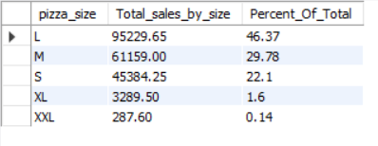

-- Top 5 best Sellers by **Revnue** , **Total Quantity and Orders**

SELECT pizza_name, SUM(total_price) AS Total_Revenue

FROM pizza_sales

GROUP BY pizza_name

ORDER BY Total_Revenue DESC

LIMIT 5;

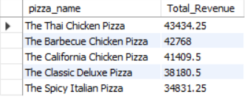

**-- QUANTITY**

SELECT pizza_name, SUM(quantity) AS Total_Quantity

FROM pizza_sales

GROUP BY pizza_name

ORDER BY Total_Quantity DESC

LIMIT 5;

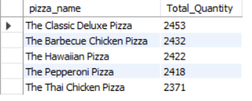

**-- ORDERS**

SELECT pizza_name, COUNT( DISTINCT order_id) AS Total_Orders

FROM pizza_sales

GROUP BY pizza_name

ORDER BY Total_Orders DESC

LIMIT 5;

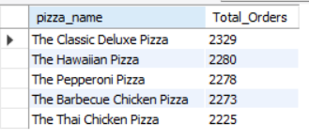

-- Top 5 least Sellers by **Revnue , Total Quantity and Orders**

**-- REVENUE**

SELECT pizza_name, SUM(total_price) AS Total_Revenue

FROM pizza_sales

GROUP BY pizza_name

ORDER BY Total_Revenue ASC

LIMIT 5;

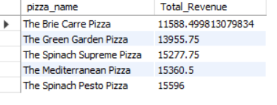

**-- QUANTITY**

SELECT pizza_name, SUM(quantity) AS Total_Quantity

FROM pizza_sales

GROUP BY pizza_name

ORDER BY Total_Quantity ASC

LIMIT 5;

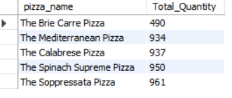

**-- ORDERS**

SELECT pizza_name, COUNT( DISTINCT order_id) AS Total_Orders

FROM pizza_sales

GROUP BY pizza_name

ORDER BY Total_Orders ASC

LIMIT 5;

